CLUSTER Toolkit for Outbreak Response


This protocol was developed as part of the CLUSTER Trial
Baker MB, Septimus EJ, Kleinman K, et al. A Trial of Automated Outbreak Detection to Reduce Hospital Pathogen Spread. NEJM Evidence 2024; 3 (5) DOI: 10.1056/EVIDoa2300342

CLUSTER Toolkit Authors

Harvard Medical School / Harvard Pilgrim Health Care Institute
Meghan Baker, M.D., Sc.D.
Ed Septimus, M.D.
Richard Platt, M.D., M.S.

University of California Irvine
Susan Huang, M.D., M.P.H.

HCA Healthcare
Julia Moody, M.S.
Eunice J. Blanchard, M.S.N., R.N.
Kenneth Sands, M.D., M.P.H.

University of California San Francisco
Deborah Yokoe, M.D. M.P.H.

Duke University
Sarah S. Lewis, M.D., M.P.H.

Rush University
Michael Lin, M.D., M.P.H.
Robert Weinstein, M.D. (also associated with Cook County Health and Hospitals System)

Table of Contents

Introduction 3
Outbreak Response Protocol: Quick Guides 4
QUICK GUIDE: Tier 1 5
QUICK GUIDE: Tier 2 14
Overview Cling 23
Activation Checklist – Initial Alert & Progression 24
Outbreak Response Protocol: Intervention Details 26
Initial Response 27
Tiers 1-5 Interventions 33
Outbreak Case List 42
Unit Notification 45
Huddle Guidance 47
Practice Assessments: Forms & Guidance Documents 49
Hand Hygiene 50
Contact Precautions 51
Environmental Cleaning: UV Marker 52
Environmental Cleaning: ATP Users 53
Chlorhexidine Bathing (for Patient Decolonization interventions) 54
Hand Hygiene Compliance Guidance 55
High Touch Surface Image Guide 56
UV Marker Removal Image Guide 57
Chlorhexidine Bathing Instructions 59
Nasal Mupirocin Application Instructions 60
Nasal Iodophor Application Instructions 61
Outbreak Response Logs 62

Introduction

The Outbreak Response Protocol provides a standardized approach to outbreaks of infections occurring in hospitals. The response protocol is focused on bacterial, mycobacterial and fungal pathogens although it could be applied to viruses. The protocol provides options for intervention when an infectious outbreak is detected in a hospital or healthcare facility. It includes an initial response plan as well as escalating tiers of strategic response if additional cases occur. Each tier requires an assessment by the infection prevention program and a response tailored to the findings of the assessment (e.g., improve hand hygiene if compliance found to be low in the setting of a cluster).
This outbreak response protocol was developed as part of the CLUSTER (Cluster Linkage Using Statistics to Trigger and Evaluate Response) Trial to assess a statistically-based automated tool to improve detection of hospital outbreaks.

Outbreak Response Protocol:
Quick Guides

Tier 1 Quick Guide

Outbreak Response Activation Checklist:

Initial Outbreak Alert

Day 1: Initial outbreak identification
☐ Step 1: Outbreak detection
☐ Step 2: Notify unit (see Notification Email), provide Staff Huddle documents & notify appropriate staff
☐ Step 3: Begin initial practice assessments: ☐ Hand Hygiene Assessment
☐ Contact Precautions Assessment (if applicable)
☐ Environmental Cleaning Assessment
Day 2
☐ Step 4: Select & begin at least ONE INTERVENTION based on practice assessment results
OPTION 1
If inadequate hand hygiene or contact precautions (<80% successful), PICK ONE:

☐ Improve hand hygiene (feedback, huddles)
☐ Improve contact precautions adherence (feedback, huddles)

OPTION 2
If inadequate adherence to environmental cleaning (<80% marks removed), PICK ONE:
☐ Improve quality of cleaning (feedback, retraining)
☐ Coordinated unit clean (conducted daily)
☐ Additional cleaning of high touch areas
☐ Step 5: Record outbreak & intervention information in Day 1-2 Outbreak Response Log
☐ Step 6: Consider collection of isolates with microbiology lab for further genetic analysis
Days 3 to 21
☐ Step 7: Continue selected intervention for 3 weeks from the date of the last case (see Outbreak Response Protocol)
☐ Step 8: Repeat the practice assessment relevant to the selected intervention weekly, until at least 3 weeks have passed from the date of the last case
Weekly Assessments Log
☐ Day 7
☐ Day 14
☐ Day 21

☐ Step 9: Complete Weekly Intervention Log on weekly basis for duration of intervention

Outbreak Response: Alert Unit

Notify unit of outbreak
- Call unit nursing and medical leadership
- Email key actions to leaders using an email template

PLEASE NOTE: Sample language and talking points can be updated by individual hospitals to reflect any facility-specific guidance or activities required. Sample text below:

Subject Header: Outbreak Alert on Your Unit
Dear Nursing Supervisor:
An outbreak of XXX has been detected on your unit. Please do the following:

- Inform all shifts about the outbreak using the outbreak huddle document.
- Remind staff:
  - Vigilant hand hygiene, including before and after glove use;
  - For patients on Contact Precautions, practice appropriate use of personal protective equipment; and
  - Disinfect equipment and devices after each patient use.
- Monitoring of hand hygiene, contact precautions (if applicable) and environmental cleaning is ongoing. Infection Control or other staff members will be visiting your unit to discuss how best to respond to the outbreak to protect your patients.
Sincerely,
XXX

Staff Huddle: Outbreak

- An outbreak of XXX has been detected on this unit

- All unit staff to assure:
  - High compliance with hand hygiene
  - Proper use of personal protective equipment for patients on Contact Precautions
  - Disinfection of equipment and devices after patient use

- Your unit manager will work with infection prevention and hospital leadership on next steps to best address this outbreak

Hand Hygiene Assessment

Date: ____/_____/________ Time: _____:______ AM/PM

Facility Name: _____________________________ Unit Name: ______________________________________

Assessment Type (Check): ___Initial Assessment Repeat Assessment: ___Week 1 ___Week 2 ___Week 3

Observer: __________________________________ Outbreak descriptor: ______________________________

Instructions:
If Partially Compliant, indicate deficiency with Quick Note: (A) Insufficient hand gel used
(B) Hands rinsed with water only (no soap)
(C) Poor technique (brief rub, little surface covered)
 | Room # | Type of Observation | Hand Hygiene Attempt  (check appropriate) |  |  | Compliance*  (check appropriate) |  |  | Quick Notes  (if Partially Compliant)
 |  | Entry, Exit, Other | Wash | Rub | None | Full | Partial | None | Indicate A, B or C
1
2
3
4
5
6
7
8
9
10
* See Hand Hygiene Compliance Criteria within toolkit for additional guidance
Overall Hand Hygiene Adherence Rate (# compliant observations / # total observations): __________________%
- ‘Partially Compliant’ not considered compliant towards adherence rate
- <80% considered poor adherence

Contact Precautions Assessment

Date: ____/_____/________ Time: _____:______ AM/PM

Facility Name: _____________________________ Unit Name: ______________________________________

Assessment Type (Check): ___Initial Assessment Repeat Assessment: ___Week 1 ___Week 2 ___Week 3

Observer: __________________________________ Outbreak descriptor: ___ ___________________________

Instructions: (1) Indicate Room # being observed & if observation is of room entry or exit
(2) Indicate observed compliance for relevant tasks (completed appropriately: Yes or No)
 | Observation 1  Room #: ______  Circle: Entry/Exit | Observation 2  Room #: ______  Circle: Entry/Exit | Observation 3  Room #: ______  Circle: Entry/Exit | Observation 4  Room #: ______  Circle: Entry/Exit | Observation 5  Room #: ______  Circle: Entry/Exit
ACTIVITY | COMPLIANCE (Yes or No)
Observation at Room Entry (skip this section for observations of room exit)
- Hand hygiene performed immediately prior to putting on gown & gloves | Yes  No | Yes  No | Yes  No | Yes  No | Yes  No
- New gown & gloves applied prior to entering room | Yes  No | Yes  No | Yes  No | Yes  No | Yes  No
Observation at Room Exit (skip this section for observations of room entry)
- Gown & gloves are removed immediately before or after room exit | Yes  No | Yes  No | Yes  No | Yes  No | Yes  No
- Hand hygiene performed immediately after gown & gloves are removed | Yes  No | Yes  No | Yes  No | Yes  No | Yes  No

Overall Contact Precautions Adherence Rate (# successful observations / # total observations) = _____________%
- Observation is successful if the all relevant tasks are done correctly
- <80% considered poor adherence

Environmental Cleaning Assessment:

UV Blacklight Marker

Date: ____/_____/________ Time: _____:______ AM/PM

Facility Name: _____________________________ Unit Name: ______________________________________

Assessment Type (Check): ___Initial Assessment Repeat Assessment: ___Week 1 ___Week 2 ___Week 3

Observer: __________________________________ Outbreak descriptor: ______________________________
CLEANING OUTCOME
0 = Not Removed
1 = Removed
Instructions for using UV Marker:
(1) Prior to daily cleaning – Mark high touch surfaces* with UV marker (2) After daily cleaning – Using UV light, assess whether marks were removed⁺
High-Touch Room Surfaces* | Room 1  PICK 5+ | Room 2  PICK 5+ | Room 3  PICK 5+ | Room 4  PICK 5+ | Room 5  PICK 5+ | Room 6  PICK 5+
Example | 1 | 1 | 0 | 1 | 0 | 1
Bed Rails / Bed Controls
Telephone
Call Button
Bedside Table
Door Knobs
Light Switch
Patient Sink Handle
Sanitizer Dispenser Button
Bathroom Sink Handle
Toilet
Toilet Flush Handle
Bathroom Hand Rails
Other: ___________________

*See High Touch Surface Image Guide within toolkit for suggested target surfaces
⁺See UV Marker Removal Image Guide within toolkit for guidance on interpreting cleaning outcome

Overall Cleaning Adherence Rate ((# clean surfaces / # total observed surfaces) = _________________%
- Individual surface is successfully cleaned if at least 80% of UV marking was removed
- <80% successfully cleaned surfaces overall considered poor adherence

Environmental Cleaning Assessment: ATP

Date: ____/_____/________ Time: _____:______ AM/PM

Facility Name: _____________________________ Unit Name: ______________________________________

Assessment Type (Check): ___Initial Assessment Repeat Assessment: ___Week 1 ___Week 2 ___Week 3

Observer: __________________________________ Outbreak descriptor: ______________________________

Instructions for ATP Users:
CLEANING OUTCOME
0 = Fail
1 = Pass
Immediately following daily room cleaning – Test high touch surfaces* for ATP
to determine if surface has been sufficiently cleaned, indicate below.
Follow manufacturer’s instruction for pass/fail threshold
High-Touch Room Surfaces* | Room 1  PICK 5+ | Room 2  PICK 5+ | Room 3  PICK 5+ | Room 4  PICK 5+ | Room 5  PICK 5+ | Room 6  PICK 5+
Example Object | 1 | 1 | 0 | 1 | 0 | 1
Bed Rails / Bed Controls
Telephone
Call Button
Bedside Table
Door Knobs
Light Switch
Patient Sink Handle
Sanitizer Dispenser Button
Bathroom Sink Handle
Toilet
Toilet Flush Handle
Bathroom Hand Rails
Other: ___________________
*See High Touch Surface Image Guide within toolkit for suggested target surfaces

Overall Cleaning Adherence Rate (# clean surfaces / # total observed surfaces) = _________________%
- Individual surface is successfully cleaned if below the manufacturer’s instructions for pass/fail threshold
- <80% successfully cleaned surfaces overall considered poor adherence

Day 1-2 Outbreak Response Log

Facility Name: _________________________________ Submitted By: ________________________________

- Outbreak Details:
  - How was the outbreak identified (describe): Click or tap here to enter text.
  - Outbreak descriptor: Click or tap here to enter text.
  - Date & Time when the outbreak was identified: Enter MMDDYY; 00:00 AM/PM
  - Date & Time of collection of first isolate in outbreak: Enter MMDDYY; 00:00 AM/PM
  - Number of patients when outbreak was identified: Click or tap here to enter text.
- Organism: Click or tap here to enter text.
- Unit Director notification: Y/N 3a. Date & Time: Enter MMDDYY; 00:00 AM/PM
- Huddles with clinical staff have occurred: Y/N
- Complete initial practice assessments (using Outbreak Response Assessment Forms) & record results:
  - Hand Hygiene Adherence Rate: ___________________%
  - Contact Precautions Adherence Rate: ______________% (Check here if N/A and not completed: ☐)
  - Environmental Cleaning Adherence Rate: ___________%
- Intervention Selected:

  - ☐ Improve hand hygiene
  - ☐ Improve contact precautions adherence
  - ☐ Improve quality of cleaning
  - ☐ Coordinated unit clean daily
  - ☐ Additional cleaning of high touch areas
  - ☐ Other (specify below)
- Intervention implementation Date & Time: Enter MMDDYY; 00:00 AM/PM
  - Description of Intervention (indicate reason for selection, e.g. poorest adherence rate): Click or tap here to enter text.
- Additional Comments: Click or tap here to enter text.

Tier 2 Quick Guide

Outbreak Response Activation Checklist:

Progression

Definition of Outbreak Progression:
A new case identified as part of an existing outbreak.
Day 1: Additional case notification
☐ Step 1: Identify one or more cases as part of an existing outbreak.
☐ Step 2: Notify unit and appropriate staff.
☐ Step 3: Repeat all practice assessments ☐ Hand Hygiene Assessment
(if >1 week has passed since initial assessments) ☐ Contact Precautions Assessment (if applicable)
☐ Environmental Cleaning Assessment
Day 2
☐ Step 4: Select & begin at least ONE ADDITIONAL INTERVENTION based on assessment results
OPTION 1
If inadequate hand hygiene or contact precautions (<80% successful), PICK ONE:

☐ Improve hand hygiene (feedback, huddles)
☐ Improve contact precautions adherence (feedback, huddles)
☐ Add universal glove precautions
☐ Add contact precautions for all patients in the outbreak

OPTION 2
If inadequate adherence to environmental cleaning (<80% marks removed), PICK ONE:
☐ Improve quality of cleaning (feedback, retraining)
☐ Coordinated unit clean (conducted daily)
☐ Additional cleaning of high touch area
☐ Step 5: Record outbreak & intervention information in Day 1-2 Outbreak Response Log: Progressions
☐ Step 6: Consider collection of isolates with microbiology lab for further genetic analysis
Days 3 to 21
☐ Step 7: Continue all selected interventions for 3 weeks from the date of the last case (see Outbreak Response Protocol)
☐ Step 8: Repeat practice assessment(s) relevant to selected intervention(s) weekly, until at least 3 weeks have passed from the date of the last case
Weekly Assessments Log
☐ Day 7
☐ Day 14
☐ Day 21

☐ Step 9: Complete Weekly Intervention Log on weekly basis for duration of intervention

Outbreak Progression: Alert Unit

Notify unit of outbreak progression
- Call unit nursing and medical leadership
- Email key actions to leaders using an email template

PLEASE NOTE: Sample language and talking points can be updated by individual hospitals to reflect any facility-specific guidance or activities required. Sample text below:

Subject Header: Outbreak Alert on Your Unit
Dear Nursing Supervisor:
A new case has been identified for the existing outbreak of XXX on your unit. Please do the following:

- Inform all shifts about the expanding outbreak using the outbreak huddle document.
- Remind staff:
  - Vigilant hand hygiene, including before and after glove use;
  - For patients on Contact Precautions, practice appropriate use of personal protective equipment; and
  - Disinfect equipment and devices after each patient use.
- Monitoring of hand hygiene, contact precautions (if applicable) and environmental cleaning is ongoing. Infection Control or other staff members will be visiting your unit to discuss how best to respond to the outbreak to protect your patients.
Sincerely,
XXX

Staff Huddle: Outbreak Progression

- The existing outbreak of XXX on this unit has progressed.

- All unit staff to assure:
  - High compliance with hand hygiene
  - Proper use of personal protective equipment for patients on Contact Precautions
  - Disinfection of equipment and devices after patient use

- Your unit manager will work with infection prevention and hospital leadership on next steps to best address this outbreak

Hand Hygiene Assessment

Date: ____/_____/________ Time: _____:______ AM/PM

Facility Name: _____________________________ Unit Name: ______________________________________

Assessment Type (Check): ___Initial Assessment Repeat Assessment: ___Week 1 ___Week 2 ___Week 3

Observer: __________________________________ Outbreak descriptor: ______________________________

Instructions:
If Partially Compliant, indicate deficiency with Quick Note: (A) Insufficient hand gel used
(B) Hands rinsed with water only (no soap)
(C) Poor technique (brief rub, little surface covered)
 | Room # | Type of Observation | Hand Hygiene Attempt  (check appropriate) |  |  | Compliance*  (check appropriate) |  |  | Quick Notes  (if Partially Compliant)
 |  | Entry, Exit, Other | Wash | Rub | None | Full | Partial | None | Indicate A, B or C
1
2
3
4
5
6
7
8
9
10
* See Hand Hygiene Compliance Criteria within toolkit for additional guidance
Overall Hand Hygiene Adherence Rate (# compliant observations / # total observations): __________________%
- ‘Partially Compliant’ not considered compliant towards adherence rate
- <80% considered poor adherence

Contact Precautions Assessment

Date: ____/_____/________ Time: _____:______ AM/PM

Facility Name: _____________________________ Unit Name: ______________________________________

Assessment Type (Check): ___Initial Assessment Repeat Assessment: ___Week 1 ___Week 2 ___Week 3

Observer: __________________________________ Outbreak descriptor: ______________________________

Instructions: (1) Indicate Room # being observed & if observation is of room entry or exit
(2) Indicate observed compliance for relevant tasks (completed appropriately: Yes or No)
 | Observation 1  Room #: ______  Circle: Entry/Exit | Observation 2  Room #: ______  Circle: Entry/Exit | Observation 3  Room #: ______  Circle: Entry/Exit | Observation 4  Room #: ______  Circle: Entry/Exit | Observation 5  Room #: ______  Circle: Entry/Exit
ACTIVITY | COMPLIANCE (Yes or No)
Observation at Room Entry (skip this section for observations of room exit)
- Hand hygiene performed immediately prior to putting on gown & gloves | Yes  No | Yes  No | Yes  No | Yes  No | Yes  No
- New gown & gloves applied prior to entering room | Yes  No | Yes  No | Yes  No | Yes  No | Yes  No
Observation at Room Exit (skip this section for observations of room entry)
- Gown & gloves are removed immediately before or after room exit | Yes  No | Yes  No | Yes  No | Yes  No | Yes  No
- Hand hygiene performed immediately after gown & gloves are removed | Yes  No | Yes  No | Yes  No | Yes  No | Yes  No

Overall Contact Precautions Adherence Rate (# successful observations / # total observations) = _____________%
- Observation is successful if the all relevant tasks are done correctly
- <80% considered poor adherence

Environmental Cleaning Assessment:

UV Blacklight Marker

Date: ____/_____/________ Time: _____:______ AM/PM

Facility Name: _____________________________ Unit Name: ______________________________________

Assessment Type (Check): ___Initial Assessment Repeat Assessment: ___Week 1 ___Week 2 ___Week 3

Observer: __________________________________ Outbreak descriptor: ______________________________
CLEANING OUTCOME
0 = Not Removed
1 = Removed
Instructions for using UV Marker:
(1) Prior to daily cleaning – Mark high touch surfaces* with UV marker (2) After daily cleaning – Using UV light, assess whether marks were removed⁺
High-Touch Room Surfaces* | Room 1  PICK 5+ | Room 2  PICK 5+ | Room 3  PICK 5+ | Room 4  PICK 5+ | Room 5  PICK 5+ | Room 6  PICK 5+
Example | 1 | 1 | 0 | 1 | 0 | 1
Bed Rails / Bed Controls
Telephone
Call Button
Bedside Table
Door Knobs
Light Switch
Patient Sink Handle
Sanitizer Dispenser Button
Bathroom Sink Handle
Toilet
Toilet Flush Handle
Bathroom Hand Rails
Other: ___________________

*See High Touch Surface Image Guide within toolkit for suggested target surfaces
⁺See UV Marker Removal Image Guide within toolkit for guidance on interpreting cleaning outcome

Overall Cleaning Adherence Rate ((# clean surfaces / # total observed surfaces) = _________________%
- Individual surface is successfully cleaned if at least 80% of UV marking was removed
- <80% successfully cleaned surfaces overall considered poor adherence

Environmental Cleaning Assessment: ATP

Date: ____/_____/________ Time: _____:______ AM/PM

Facility Name: _____________________________ Unit Name: ______________________________________

Assessment Type (Check): ___Initial Assessment Repeat Assessment: ___Week 1 ___Week 2 ___Week 3

Observer: __________________________________ Outbreak descriptor: ______________________________

Instructions for ATP Users:
CLEANING OUTCOME
0 = Fail
1 = Pass
Immediately following daily room cleaning – Test high touch surfaces* for ATP
to determine if surface has been sufficiently cleaned, indicate below.
Follow manufacturer’s instruction for pass/fail threshold
High-Touch Room Surfaces* | Room 1  PICK 5+ | Room 2  PICK 5+ | Room 3  PICK 5+ | Room 4  PICK 5+ | Room 5  PICK 5+ | Room 6  PICK 5+
Example Object | 1 | 1 | 0 | 1 | 0 | 1
Bed Rails / Bed Controls
Telephone
Call Button
Bedside Table
Door Knobs
Light Switch
Patient Sink Handle
Sanitizer Dispenser Button
Bathroom Sink Handle
Toilet
Toilet Flush Handle
Bathroom Hand Rails
Other: ___________________
*See High Touch Surface Image Guide within toolkit for suggested target surfaces

Overall Cleaning Adherence Rate (# clean surfaces / # total observed surfaces) = _________________%
- Individual surface is successfully cleaned if below the manufacturer’s instructions for pass/fail threshold
- <80% successfully cleaned surfaces overall considered poor adherence

Day 1-2 Outbreak Response Log: TIER 2 Progression of Outbreak

Facility Name: _________________________________ Submitted By: _________________________________

- Outbreak Progression Details:
  - Outbreak descriptor: Click or tap here to enter text.
  - Date & Time when outbreak progression was identified: Enter MMDDYY; 00:00 AM/PM
  - Date & Time of collection of most recent isolate: Enter MMDDYY; 00:00 AM/PM
  - Number of additional patients: Click or tap here to enter text.
  - Please describe how the outbreak has progressed: Click or tap here to enter text.
- Huddles with clinical staff have occurred: Y/N
- Complete repeat practice assessments (if >1week has passed since initial assessments) & record results:
- Hand Hygiene Adherence Rate: ___________________%
- Contact Precaution Adherence Rate: _______________% (Check here if N/A and not completed: ☐)
- Environmental Cleaning Adherence Rate: ___________%
- Tier 2 intervention selected:

  - ☐ Improve hand hygiene
  - ☐ Improve contact precaution adherence
  - ☐ Add universal glove precautions
  - ☐ Add contact precautions for outbreak patients
  - ☐ Improve quality of cleaning
  - ☐ Coordinated unit clean daily
  - ☐ Additional cleaning of high touch areas
  - ☐ Other (specify below)

- Second intervention implementation Date & Time: Enter MMDDYY; 00:00 AM/PM
  - Description of intervention (indicate reason for selection, e.g. poorest adherence rate): Click or tap here to enter text.
- Additional Comments: Click or tap here to enter text.

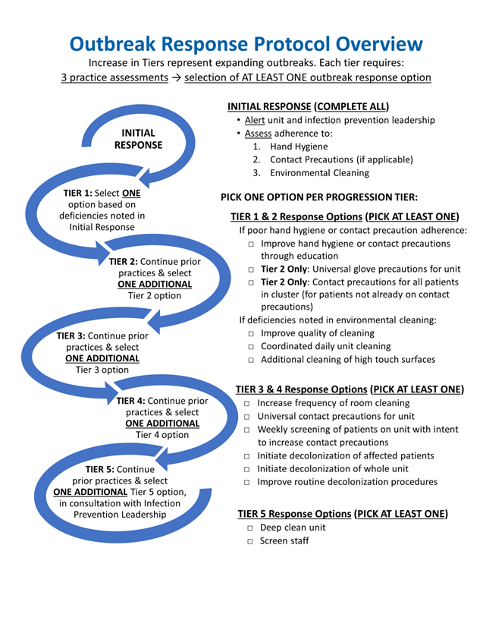

Outbreak Response Activation Checklist:

Initial Outbreak Alert

Day 1: Initial outbreak identification
☐ Step 1: Outbreak detection
☐ Step 2: Notify unit (see Notification Email), provide Staff Huddle documents & notify appropriate staff
☐ Step 3: Begin initial practice assessments: ☐ Hand Hygiene Assessment
☐ Contact Precautions Assessment (if applicable)
☐ Environmental Cleaning Assessment
Day 2
☐ Step 4: Select & begin at least ONE INTERVENTION based on practice assessment results for intervention details, see Outbreak Response Protocol
☐ Step 5: Record outbreak & intervention information in Day 1-2 Outbreak Response Log
☐ Step 6: Consider collection of isolates with microbiology lab for further genetic analysis
Days 3 to 21
☐ Step 7: Continue selected intervention for 3 weeks from the date of the last case (see Outbreak Response Protocol)
☐ Step 8: Repeat the practice assessment relevant to the selected intervention weekly, until at least 3 weeks have passed from the date of the last case
Weekly Assessments Log
☐ Day 7
☐ Day 14
☐ Day 21

☐ Step 9: Complete Weekly Intervention Log on weekly basis for duration of intervention

Outbreak Response Activation Checklist:

Outbreak Progression

Definition of Outbreak Progression:
A new case identified as part of an existing outbreak.
Day 1: Additional case notification
☐ Step 1: Identify one or more cases as part of an existing outbreak.
☐ Step 2: Notify unit and appropriate staff.
☐ Step 3: Repeat all practice assessments ☐ Hand Hygiene Assessment
(if >1 week has passed since initial assessments) ☐ Contact Precautions Assessment (if applicable)
☐ Environmental Cleaning Assessment
Day 2
☐ Step 4: Select & begin at least ONE ADDITIONAL INTERVENTION based on assessment results & tier for intervention details, see Outbreak Response Protocol
☐ Step 5: Record outbreak & intervention information in Day 1-2 Outbreak Response Log: Progressions
☐ Step 6: Consider collection of isolates with microbiology lab for further genetic analysis
Days 3 to 21
☐ Step 7: Continue all selected interventions for 3 weeks from the date of the last case (see Outbreak Response Protocol)
☐ Step 8: Repeat practice assessment(s) relevant to selected intervention(s) weekly, until at least 3 weeks have passed from the date of the last case
Weekly Assessments Log
☐ Day 7
☐ Day 14
☐ Day 21

☐ Step 9: Complete Weekly Intervention Log on weekly basis for duration of intervention

Outbreak Response Protocol:
Intervention Details

Outbreak Response Protocol: INITIAL RESPONSE

ELEMENTS | DETAILED DESCRIPTION
Initial Response | Following identification of an outbreak, complete all mandatory Initial Response tasks & assessments, before selecting a Tier 1 Intervention Option.  PLEASE NOTE: If an outbreak is identified over the weekend or on a holiday, initiate alert notification and huddles, and begin assessments when possible (at latest, the next business day).
Alert Unit & Lab Personnel | Notify the Unit: Please find “Outbreak Response: Alert Unit” document for an email template.  Consider collection of isolates with microbiology lab for future genetic analysis.
Team Huddle | Conduct team huddle with nursing or medical director, nursing staff and environmental services to discuss the outbreak and the response plan.  See Staff Huddle: Outbreak document for further guidance.
Practice Assessments: Hand Hygiene  Assess adherence | Designated staff trained in hand hygiene monitoring should observe at least 5 hand hygiene opportunities per 10 unit beds for 5 different healthcare workers in units where the outbreak was detected, and record hand hygiene adherence using the Hand Hygiene Assessment Form in the toolkit.  Who should do the assessment? This decision is based upon what has been agreed upon or what is usual practice at your hospital. For example, this could be a unit nursing director/manager, designated nursing staff, infection preventionist, trained ancillary staff or volunteer.  Hand hygiene opportunities refers to room entry, room exit, or in-room opportunities per the 5 WHO moments (note: the observer must have full view to assess the opportunity). Opportunities include:  - washing with soap and water  - using alcohol-based hand rub  Appropriate hand hygiene:  - Washing hands with soap and water for 15 seconds  - Rubbing approved hand sanitizer on all hand surfaces  - If gloves are used, hand hygiene performed prior to donning gloves and after removal  - For C. difficile precaution rooms, healthcare personnel must perform hand hygiene (e.g. soap and water) upon exit, in accordance with hospital policy.  - Please see the Hand Hygiene Compliance Criteria for additional guidance  Observers are encouraged to provide real-time feedback to healthcare workers to correct hand hygiene practices, while recording originally observed practices in assessment form.

Practice Assessments: Contact Precautions (Gown & Glove)  Assess adherence, if applicable | If the outbreak organism is one that involves contact precautions, perform this assessment. Otherwise, SKIP.  Designated staff trained in contact precautions monitoring should observe at least 5 contact precaution opportunities per involved unit for 5 different health care workers, and record adherence using the Contact Precautions Assessment Form in the toolkit.  Who should do the assessment? This decision is based upon what has been agreed upon or what is usual practice at your hospital. For example, this could be a unit nursing director/manager, designated nursing staff, infection preventionist, trained ancillary staff or volunteer.  Contact Precaution opportunities refer to donning on entry or doffing on exit from room.  Appropriate use of contact precautions:  - Perform hand hygiene.  - Don gown & gloves just prior to room entry. Gown should be secured at neck and waist.  - Gowns & gloves removed at room exit.  - Hand hygiene performed after glove removal.  - Additional contact precaution requirements per hospital policy  Observers are encouraged to provide real-time feedback to healthcare workers to correct contact precaution practices, while recording originally observed practices in assessment form.

Practice Assessments: Environmental Cleaning  Assess adequacy of environmental cleaning | Designated staff should assess the quality of cleaning of in at least 2 rooms per affected unit, and no less than 1 of every 10 rooms on unit (at least 5 high touch surfaces per patient room or patient area), using either UV marker or ATP. For both methods, selected surfaces & cleaning outcome should be recorded using the Environmental Cleaning Assessment Form in the toolkit.  Please see the High Touch Surface Image Guide for the types of surfaces to select.  Who should do the assessment? This decision is based upon what has been agreed upon or what is usual practice at your hospital. For example, this could be a unit nursing director/manager, designated nursing staff, infection preventionist, EVS, trained ancillary staff or volunteer.  If using UV marker:  Prior to scheduled room cleaning, mark high touch surfaces with UV marker or spray. Return after scheduled cleaning time with blacklight to see if UV marks were removed with daily or terminal cleaning. A marked surface is considered successfully cleaned if at least 80% of the UV marks are removed. Document marked surfaces and cleaning outcome accordingly.  Please see the UV Marker Removal Image Guide for guidance on interpreting cleaning outcome.  If using ATP:  Immediately following daily room cleaning, test selected surfaces for ATP to determine if surfaces have been sufficiently cleaned. An individual surface is successfully cleaned if below the manufacturer’s instructions for the pass/fail threshold. Document observed surfaces and cleaning outcome accordingly.
Intervention Selection & Duration | Using results from practice assessments, select 1 intervention to implement from the options provided for that Tier.  Selected interventions for all Tiers (1 through 5) should be implemented and followed for 3 weeks from the date of the most recent case.  NOTE: At the discretion of the Infection Preventionist or Hospital Epidemiologist, intervention duration may be extended beyond 21 days.
Outbreaks Affecting Multiple Units | Conduct assessments and intervene on all affected units.  Assessments should be performed for each unit affected.  Intervention: select 1 intervention for each affected unit based on initial assessments. If units show different deficiencies, different interventions can be selected, implementing at least one intervention in all units. NOTE: document all intervention selection(s) and unit(s) in the “Day 1-2 Outbreak Response Log”.

Ongoing Practice Assessments | Following intervention implementation for all Tiers (1 through 5), repeat the practice assessments relevant to the selected intervention(s) weekly until at least 3 weeks have passed from the time of the last case. Document and report the following:  Initial Assessments:  Start on Day 1 of outbreak detection (or as soon as possible)  Document results: “Day 1-2 Outbreak Response Log”  Weekly Assessments:  Complete weekly, (e.g. days 7, 14 and 21)  Document results: “Weekly Intervention Log”  If the outbreak progresses (additional cases identified), repeat all practice assessments: hand hygiene and environmental cleaning assessments, and contact precautions assessment (if appropriate) if performed more than one week ago.  Continue weekly assessments until at least 3 weeks have passed from the time of the last case.

Outbreak Response Protocol: TIER 1

ELEMENTS | DETAILED DESCRIPTION
TIER 1: Initial Outbreak Detection  SELECT ONE Tier 1 intervention to implement, from EITHER:  Option 1 (A-B), OR  Option 2 (C-E) | Selection: Select one of the Tier 1 interventions (from either Option 1 or Option 2), based on initial practice assessments, (if no deficiencies noted, choose any one of the options):  Tier 1 Option 1: Inadequate adherence to hand hygiene or contact precautions is defined as <80% adherence.  Tier 1 Option 2: Deficiencies noted in cleaning are defined as <80% of observed surfaces sufficiently cleaned.  Intervention Duration: Selected intervention should be implemented & followed for 3 weeks from the date of the most recent case.

TIER 1 – OPTION 1:  If poor adherence to hand hygiene or contact precautions, SELECT ONE Option 1 intervention (A-B):  - Improve hand hygiene adherence to ≥80% | - Through education or clinical care staff huddles, increase hand hygiene adherence to ≥80%.
- Improve contact precautions adherence to ≥80% | - Through education or clinical care staff huddles, increase contact precautions adherence to ≥80%.
TIER 1 – OPTION 2:  If deficiencies are noted in environmental cleaning, SELECT ONE Option 2 intervention (C-E):  - Improve quality of cleaning | - Work with staff who are conducting the cleaning to improve the quality of cleaning and monitor with goal of >80% observed surfaces sufficiently cleaned after daily or terminal room cleaning.
- Coordinated additional clean of unit (daily) | - Local staff and/or EVS to conduct additional coordinated daily cleaning of affected rooms and unit common areas, including cleaning of high touch items/areas (such as computer keyboards, medication preparation areas, counters, common sinks).
- Add additional cleaning of high touch areas and items | - Nursing staff, floor staff and/or EVS clean high touch surfaces with the standard disinfecting wipes or solution used at the hospital, at least once per day. Please see the High Touch Surface Image Guide for the types of surfaces to select.

Outbreak Response Protocol:

TIER 2

ELEMENTS | DETAILED DESCRIPTION
TIER 2: Outbreak Progression  SELECT ONE ADDITIONAL Tier 2 intervention to implement, from EITHER:  Option 1 (A-D), OR  Option 2 (E-G) | Selection: In the event of an additional case in the outbreak, continue prior processes and select one additional Tier 2 intervention to implement.  The choice of the second intervention option should be based on deficiencies noted in the most recent assessments, (if more than 1 week has passed since initial assessments, repeat assessments should be completed). If no deficiencies are noted, select any additional intervention.  Intervention Duration: Both selected interventions should be implemented & followed for 3 weeks from the date of the last case.

TIER 2 – OPTION 1:  If poor adherence to hand hygiene or contact precautions, SELECT ONE:  - Improve hand hygiene adherence to ≥80% | - Through education or clinical care staff huddles, increase hand hygiene adherence to ≥80%.
- Improve contact precautions adherence to ≥80% | - Through education or clinical care staff huddles, increase contact precautions adherence to ≥80%.
- Newly institute universal glove precautions when caring for patients on the unit (for patients not already on contact precautions) | - All staff entering the patient rooms or patient space (e.g., bay of a multi-person room) on the unit should perform routine hand hygiene and then don gloves. Gloves should be removed immediately upon exiting the patient rooms followed by hand hygiene.
- Newly institute contact precautions for all patients that are part of an outbreak (for patients not already on contact precautions) | - All staff entering the patient rooms or patient space (e.g., bay of a multi-person room) of those patients involved in the outbreak, should perform routine hand hygiene and then don gloves & gowns (tied appropriately). Gloves & gowns should be removed immediately upon exiting the patient room followed by hand hygiene.
TIER 2 – OPTION 2:  If deficiencies are noted in environmental cleaning, SELECT ONE:  - Improve quality of cleaning | - Improve the quality of cleaning and monitor with goal of >80% observed surfaces sufficiently cleaned after daily or terminal room cleaning.
- Coordinated additional clean of unit (daily) | - Local staff and/or EVS to conduct additional coordinated daily cleaning of affected rooms and unit common areas, including cleaning of high touch items/areas (such as keyboards, medication preparation areas, counters, common sinks).
- Add additional cleaning of high touch areas and items | - Nursing staff, floor staff and/or EVS clean high touch surfaces with the standard disinfecting wipes or solution used at the hospital, at least once per day. Please see the High Touch Surface Image Guide for the types of surfaces to select.

Outbreak Response Protocol: TIER 3

ELEMENTS | DETAILED DESCRIPTION
TIER 3: Outbreak Progression  SELECT ONE ADDITIONAL Tier 3 intervention to implement, (select from the Tier 3 options, A-F) | Selection: In the event of additional cases in the outbreak, continue prior processes and select one additional intervention option below to implement.  The choice of the Tier 3 intervention option should be based on deficiencies noted in the most recent assessments, (if more than 1 week has passed since initial assessments, repeat assessments should be completed). If no deficiencies are noted, select any additional intervention.  Intervention Duration: All selected interventions should be implemented & followed for 3 weeks from the date of the last case.  NOTE: If an outbreak reaches a Tier 3 Progression, local Infection Prevention team should consider discussing outbreak with leadership if they have not already.
- Increase room cleaning to twice daily | - Environmental services increase cleaning to twice daily cleaning of all patient rooms in affected unit rather than once per day.
- Universal contact precautions for the unit | - Institute universal contact precautions for the unit.
- Weekly screens of patients on unit with intent to increase contact precautions (if MDRO outbreak) | - Nares/skin screen if MRSA or MSSA; rectal/skin screen if VRE, ESBL, CRE, or other enteric. Place patients on contact precautions if noted to be colonized with the relevant organism or another MDRO.

- Initiate decolonization of affected patients (if not already routinely done) | - Please follow CHG Bath Handout instructions in the toolkit.  In consultation with leadership, initiate CHG bathing daily for patients involved in the outbreak, for the duration of the intervention. For patients known to be colonized with MRSA/MSSA, add nasal decolonization with twice-daily intranasal mupirocin or iodophor, (depending on your hospital preference/protocol). Please follow either the Nasal Mupirocin Handout or Nasal Iodophor Handout instructions in the toolkit.
- Initiate decolonization of whole unit (if not already routinely done) | - Please follow CHG Bath Handout instructions in the toolkit.  In consultation with leadership, initiate CHG bathing daily for whole unit, for the duration of the intervention. For patients known to be colonized with MRSA/MSSA, please add nasal decolonization with twice-daily intranasal mupirocin or iodophor, (depending on your hospital protocol). Please follow either the Nasal Mupirocin Handout or Nasal Iodophor Handout instructions in the toolkit.
- If unit is already performing routine decolonization procedures, add increased attention to process | - Please follow CHG Bath Handout instructions in the toolkit.  Perform at least 5 observations of CHG bathing techniques in units where outbreak was detected (and CHG cloths are used), and record observation outcomes using the CHG Bathing Observation Assessment in the toolkit.  This assessment form should be used as a tool to guide targeted re-education of proper technique. If <80% of observations are completed successfully, re-education on proper technique is required.  Complete 5 observations each week, for three weeks from the last outbreak case alert.

Outbreak Response Protocol: TIER 4

ELEMENTS | DETAILED DESCRIPTION
TIER 4: Outbreak Progression  SELECT ONE ADDITIONAL Tier 4 intervention to implement, (from Tier 3 options A-F) | Selection: In the event of additional cases in the outbreak, continue prior processes and select one additional intervention option to implement.  The choice of the additional intervention option should be based on deficiencies noted in the most recent assessments, (if more than 1 week has passed since initial assessments, repeat assessments should be completed). If no deficiencies are noted, select any additional intervention.  Intervention Duration: All selected interventions should be implemented & followed for 3 weeks from the date of the last case.
- Increase room cleaning to twice daily | - Environmental services increase cleaning to twice daily cleaning of all patient rooms in affected unit rather than once per day.
- Universal contact precautions for the unit | - Institute universal contact precautions for the unit.
- Weekly screens of patients on unit with intent to increase contact precautions (if MDRO outbreak) | - Nares/skin screen if MRSA or MSSA; rectal/skin screen if VRE, ESBL, CRE, or other enteric. Place patients on contact precautions if noted to be colonized with the relevant organism or another MDRO.

- Initiate decolonization of affected patients (if not already routinely done) | - Please follow CHG Bath Handout instructions in the toolkit.  In consultation with leadership, initiate CHG bathing daily for patients involved in the outbreak, for the duration of the intervention. For patients known to be colonized with MRSA/MSSA, add nasal decolonization with twice-daily intranasal mupirocin or iodophor, (depending on your hospital preference/protocol). Please follow either the Nasal Mupirocin Handout or Nasal Iodophor Handout instructions in the toolkit.
- Initiate decolonization of whole unit (if not already routinely done) | - Please follow CHG Bath Handout instructions in the toolkit.  In consultation with leadership, initiate CHG bathing daily for whole unit, for the duration of the intervention. For patients known to be colonized with MRSA/MSSA, please add nasal decolonization with twice-daily intranasal mupirocin or iodophor, (depending on your hospital protocol). Please follow either the Nasal Mupirocin Handout or Nasal Iodophor Handout instructions in the toolkit.
- If unit is already performing routine decolonization procedures, add increased attention to process | - Please follow CHG Bath Handout instructions in the toolkit.  Perform at least 5 observations of CHG bathing techniques in units where outbreak was detected (and CHG cloths are used), and record observation outcomes using the CHG Bathing Observation Assessment in the toolkit.  This assessment form should be used as a tool to guide targeted re-education of proper technique. If <80% of observations are completed successfully, re-education on proper technique is required.  Complete 5 observations each week, for 3 weeks from the last outbreak case alert.

Outbreak Response Protocol:

TIER 5

ELEMENTS | DETAILED DESCRIPTION
TIER 5: Outbreak Progression  SELECT ONE ADDITIONAL Tier 5 intervention to implement, (select from Tier 5 options) | Selection: In the event of additional cases reaching a Tier 5 outbreak progression, active discussion should be ongoing with leadership and consider including local department of public health if they are not already involved.
- Deep Clean Unit | - Patients to be moved out of each room so that a terminal clean can be performed. Unit may be vacated all at once if census is low, or patients can be moved out in stages to accommodate the deep cleaning. All rooms in the unit to be terminally cleaned. All common areas to receive a deep clean.
- Screen Staff | - For organisms amenable to screening (e.g. MRSA, MSSA, and certain highly resistant organisms), perform a point prevalence screen of staff to identify if any staff members are a source of ongoing transmission. This decision should be made with hospital leadership and key stakeholders.

Outbreak: Case List
Facility Name: |  |  |  |  |  |  |  |  |  |  |  |  |  |  |  | Submitted by: |  |  |  |  |  |  |  |  |  |  |  |  |  |  |  |  | Date:
Section 1. Outbreak Information

Outbreak Descriptor |  |  | Organism |  |  |  | Date of First Isolate  Collection Date |  |  |  |  | Initial Outbreak Identification  Date & Time |  |  |  |  |  |  | # Cases when detected  Should match # cases noted as 'Initial Outbreak' below |  |  |  |  |  |  |  | Resistance Pattern  Does it match across isolates?  If no, how does it differ? |  |  |  |  |  |  |  | Describe How Outbreak Was Detected
Section 2. Outbreak Case
Case |  | Case Type |  | If Progression: Date & Time of Identification |  | Specimen ID |  |  | Last Name |  |  |  |  | First Name |  |  | MRN |  |  |  |  | Admission Date |  |  |  |  |  | Collection Date |  |  |  |  |  | Specimen Source |  |  |  |  | Collection Location
1 |  | ☐ Initial Outbreak
2 |  | ☐ Initial Outbreak
3 |  | ☐ Initial Outbreak  ☐ Progression
4 |  | ☐ Initial Outbreak  ☐ Progression
5 |  | ☐ Initial Outbreak  ☐ Progression
6 |  | ☐ Initial Outbreak  ☐ Progression
7 |  | ☐ Initial Outbreak  ☐ Progression
8 |  | ☐ Initial Outbreak  ☐ Progression
Section 3. IP Notes

Outbreak Alert Communication:
Templates & Forms

Unit Notification Email Templates
Initial Outbreak Alert & Outbreak Progression
Staff Huddle Guidance
Initial Outbreak Alert & Outbreak Progression

Outbreak Response: Unit Notification

Notify unit of outbreak
- Call unit nursing and medical leadership
- Email key actions to leaders using an email template

PLEASE NOTE: Sample language and talking points can be updated by individual hospitals to reflect any facility-specific guidance or activities required. Sample text below:

Subject Header: Outbreak Alert on Your Unit
Dear Nursing Supervisor:
An outbreak of XXX has been detected on your unit. Please do the following:

- Inform all shifts about the outbreak using the outbreak huddle document.
- Remind staff:
  - Vigilant hand hygiene, including before and after glove use;
  - For patients on Contact Precautions, practice appropriate use of personal protective equipment; and
  - Disinfect equipment and devices after each patient use.
- Monitoring of hand hygiene, contact precautions (if applicable) and environmental cleaning is ongoing. Infection Control or other staff members will be visiting your unit to discuss how best to respond to the outbreak to protect your patients.
Sincerely,
XXX

Outbreak Progression: Unit Notification

Notify unit of outbreak progression
- Call unit nursing and medical leadership
- Email key actions to leaders using an email template
PLEASE NOTE: Sample language and talking points can be updated by individual hospitals to reflect any facility-specific guidance or activities required. Sample text below:

Subject Header: Outbreak on Your Unit
Dear Nursing Supervisor:
A new case has been identified for the existing outbreak of XXX on your unit. Please do the following:

- Inform all shifts about the expanding outbreak using the outbreak huddle document.
- Remind staff:
  - Vigilant hand hygiene, including before and after glove use;
  - For patients on Contact Precautions, practice appropriate use of personal protective equipment; and
  - Disinfect equipment and devices after each patient use.
- Monitoring of hand hygiene, contact precautions (if applicable) and environmental cleaning is ongoing. Infection Control or other staff members will be visiting your unit to discuss how best to respond to the outbreak to protect your patients.
Sincerely,
XXX

Staff Huddle: Outbreak

- An outbreak of XXX has been detected on this unit

- All unit staff to assure:
  - High compliance with hand hygiene
  - Proper use of personal protective equipment for patients on Contact Precautions
  - Disinfection of equipment and devices after patient use

- Your unit manager will work with infection prevention and hospital leadership on next steps to best address this outbreak.

Staff Huddle: Outbreak Progression

- The existing outbreak of XXX on this unit has progressed

- XX new cases have been identified

- All unit staff to assure:
  - High compliance with hand hygiene
  - Proper use of personal protective equipment for patients on Contact Precautions
  - Disinfection of equipment and devices after patient use

- Your unit manager will work with infection prevention and hospital leadership on next steps to best address this outbreak.

Practice Assessments
Assessment Forms
- Hand Hygiene
- Contact Precautions (when applicable)
- Environmental Cleaning: UV Marker
- Environmental Cleaning: ATP
- Chlorhexidine Bathing tool for Tier 3-4 intervention options related to patient decolonization
Assessment Guidance Documents
- Hand Hygiene Compliance Guidance Document
- High Touch Surface Image Guide
- UV Marker Removal Image Guide
- Patient Decolonization Staff Handouts:
  - Chlorhexidine Bathing Instructions
  - Nasal Mupirocin Application Instructions
  - Nasal Iodophor Application Instructions

Hand Hygiene Assessment

Date: ____/_____/________ Time: _____:______ AM/PM

Facility Name: _____________________________ Unit Name: ______________________________________

Assessment Type (Check): ___Initial Assessment Repeat Assessment: ___Week 1 ___Week 2 ___Week 3

Observer: __________________________________ Outbreak descriptor: ______________________________

Instructions:
If Partially Compliant, indicate deficiency with Quick Note: (A) Insufficient hand gel used
(B) Hands rinsed with water only (no soap)
(C) Poor technique (brief rub, little surface covered)
 | Room # | Type of Observation | Hand Hygiene Attempt  (check appropriate) |  |  | Compliance*  (check appropriate) |  |  | Quick Notes  (if Partially Compliant)
 |  | Entry, Exit, Other | Wash | Rub | None | Full | Partial | None | Indicate A, B or C
1
2
3
4
5
6
7
8
9
10
* See Hand Hygiene Compliance Criteria within toolkit for additional guidance
Overall Hand Hygiene Adherence Rate (# compliant observations / # total observations): __________________%
- ‘Partially Compliant’ not considered compliant towards adherence rate
- <80% considered poor adherence

Contact Precautions Assessment

Date: ____/_____/________ Time: _____:______ AM/PM

Facility Name: _____________________________ Unit Name: ______________________________________

Assessment Type (Check): ___Initial Assessment Repeat Assessment: ___Week 1 ___Week 2 ___Week 3

Observer: __________________________________ Outbreak descriptor: ______________________________

Instructions: (1) Indicate Room # being observed & if observation is of room entry or exit
(2) Indicate observed compliance for relevant tasks (completed appropriately: Yes or No)
 | Observation 1  Room #: ______  Circle: Entry/Exit | Observation 2  Room #: ______  Circle: Entry/Exit | Observation 3  Room #: ______  Circle: Entry/Exit | Observation 4  Room #: ______  Circle: Entry/Exit | Observation 5  Room #: ______  Circle: Entry/Exit
ACTIVITY | COMPLIANCE (Yes or No)
Observation at Room Entry (skip this section for observations of room exit)
- Hand hygiene performed immediately prior to putting on gown & gloves | Yes  No | Yes  No | Yes  No | Yes  No | Yes  No
- New gown & gloves applied prior to entering room | Yes  No | Yes  No | Yes  No | Yes  No | Yes  No
Observation at Room Exit (skip this section for observations of room entry)
- Gown & gloves are removed immediately before or after room exit | Yes  No | Yes  No | Yes  No | Yes  No | Yes  No
- Hand hygiene performed immediately after gown & gloves are removed | Yes  No | Yes  No | Yes  No | Yes  No | Yes  No

Overall Contact Precautions Adherence Rate (# successful observations / # total observations) = _____________%
- Observation is successful if the all relevant tasks are done correctly
- <80% considered poor adherence

Environmental Cleaning Assessment:

UV Blacklight Marker

Date: ____/_____/________ Time: _____:______ AM/PM

Facility Name: _____________________________ Unit Name: ______________________________________

Assessment Type (Check): ___Initial Assessment Repeat Assessment: ___Week 1 ___Week 2 ___Week 3

Observer: __________________________________ Outbreak descriptor: ____________________________________
CLEANING OUTCOME
0 = Not Removed
1 = Removed
Instructions for using UV Marker:
(1) Prior to daily cleaning – Mark high touch surfaces* with UV marker (2) After daily cleaning – Using UV light, assess whether marks were removed⁺
High-Touch Room Surfaces* | Room 1  PICK 5+ | Room 2  PICK 5+ | Room 3  PICK 5+ | Room 4  PICK 5+ | Room 5  PICK 5+ | Room 6  PICK 5+
Example | 1 | 1 | 0 | 1 | 0 | 1
Bed Rails / Bed Controls
Telephone
Call Button
Bedside Table
Door Knobs
Light Switch
Patient Sink Handle
Sanitizer Dispenser Button
Bathroom Sink Handle
Toilet
Toilet Flush Handle
Bathroom Hand Rails
Other: ___________________

*See High Touch Surface Image Guide within toolkit for suggested target surfaces
⁺See UV Marker Removal Image Guide within toolkit for guidance on interpreting cleaning outcome

Overall Cleaning Adherence Rate ((# clean surfaces / # total observed surfaces) = _________________%
- Individual surface is successfully cleaned if at least 80% of UV marking was removed
- <80% successfully cleaned surfaces overall considered poor adherence

Environmental Cleaning Assessment: ATP

Date: ____/_____/________ Time: _____:______ AM/PM

Facility Name: _____________________________ Unit Name: ______________________________________

Assessment Type (Check): ___Initial Assessment Repeat Assessment: ___Week 1 ___Week 2 ___Week 3

Observer: __________________________________ Outbreak descriptor: ______________________________

Instructions for ATP Users:
CLEANING OUTCOME
0 = Fail
1 = Pass
Immediately following daily room cleaning – Test high touch surfaces* for ATP
to determine if surface has been sufficiently cleaned, indicate below.
Follow manufacturer’s instruction for pass/fail threshold
High-Touch Room Surfaces* | Room 1  PICK 5+ | Room 2  PICK 5+ | Room 3  PICK 5+ | Room 4  PICK 5+ | Room 5  PICK 5+ | Room 6  PICK 5+
Example Object | 1 | 1 | 0 | 1 | 0 | 1
Bed Rails / Bed Controls
Telephone
Call Button
Bedside Table
Door Knobs
Light Switch
Patient Sink Handle
Sanitizer Dispenser Button
Bathroom Sink Handle
Toilet
Toilet Flush Handle
Bathroom Hand Rails
Other: ___________________
*See High Touch Surface Image Guide within toolkit for suggested target surfaces

Overall Cleaning Adherence Rate (# clean surfaces / # total observed surfaces) = _________________%
- Individual surface is successfully cleaned if below the manufacturer’s instructions for pass/fail threshold
- <80% successfully cleaned surfaces overall considered poor adherence

CHG Bathing Observation Assessment
Assessment Tool for Tier 3 & 4 Response Protocol: Improved Decolonization Procedures

Date: ____/_____/________ Time: _____:______ AM/PM

Facility Name: _____________________________ Unit Name: ______________________________________

Assessment Type (Check): ___Initial Assessment Repeat Assessment: ___Week 1 ___Week 2 ___Week 3

Observer: __________________________________ Outbreak descriptor: ______________________________

Instructions: Indicate who is giving bath & whether each step was completed (Yes, No, N/A) for each observation.
Note: Form should be used as a tool to guide targeted re-education of proper bathing technique.

 | Patient 1 | Patient 2 | Patient 3 | Patient 4 | Patient 5
Individual Giving CHG Bath
Indicate RN or CNA
CHG Cloth Bathing Practice Observations (indicate Yes, No, or N/A)
- Massaged skin firmly with CHG cloth
- Cleaned face and neck well
- Cleaned between fingers and toes
- Cleaned between all folds
- Cleaned occlusive & semi-permeable dressings
- Cleaned 6 inches of all tubes, central lines & drains closest to body
- Used CHG on superficial wounds, rash, and stage 1 & 2 decubitus ulcers
- Used CHG on surgical wounds (unless primary dressing or packed)
- Allowed CHG to air-dry / does not wipe off CHG
10. Disposed of used cloths in trash / does not flush

Overall CHG Bathing Adherence Rate (# successful observations / # total observations) = _________________%
- Observation is successful if 8 of the 10 steps are completed correctly
- <80% successful overall is considered poor adherence and requires re-education

Hand Hygiene Compliance Criteria

Compliant | Non-Compliant
Washing with soap & water or alcohol-based hand rub | Rinsing hands with water only;  Used alcohol instead of soap and water per facility policy;  Dispensed product less than recommended amount;  Performed for less than vendor recommended amount of time;  Hand hygiene moment missed entirely on entry or exit
Hand wash or alcohol-based hand rub before glove use | No hand wash or no alcohol-based hand rub before glove use
Hand wash or alcohol-based hand rub after glove removal | No hand wash or no alcohol-based hand rub after glove removal
Hand wash or alcohol-based hand rub between patients | No hand wash or no alcohol-based hand rub between patients
Applying soap and water to lather or rubbing alcohol-based hand rub on all hand surfaces | Brief rub and/or little surface covered;  For example:  - Applied to palms only (back of hands missed)  - Did not apply between fingers  - Minimal contact, no rubbing

Image Guide for Cleaning High Touch Surfaces
SUGGESTED TARGET PLACEMENT ON HIGH TOUCH OBJECTS
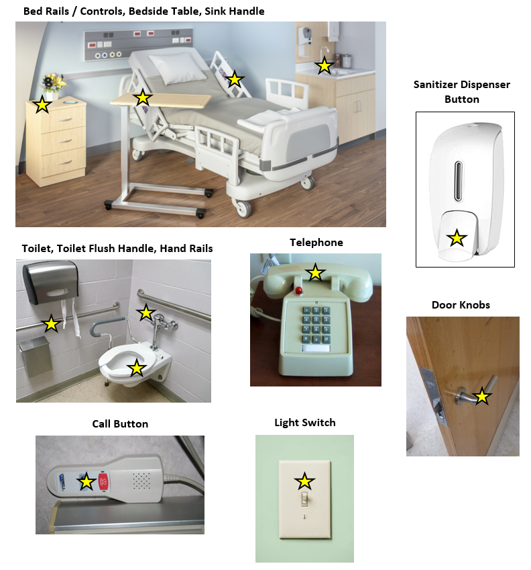

UV Marker Removal Image Guide

UV Blacklight Marker
Refer to manufacturer’s instructions for use and the below guidance for acceptable levels for marking removal. In general, a surface is sufficiently cleaned is if the UV marker is at least 80% removed.

Example Images Showing UV Marks Removed or Not Removed:

UV MARKING SPRAY REMOVAL: DOOR KNOB
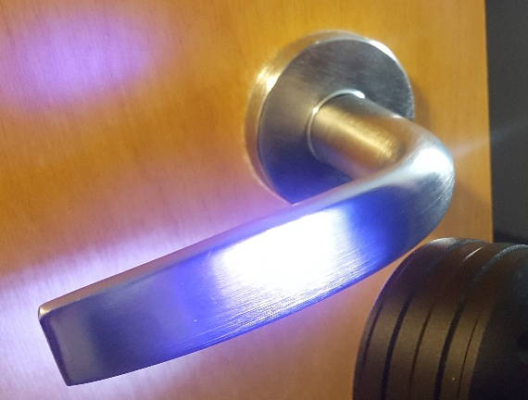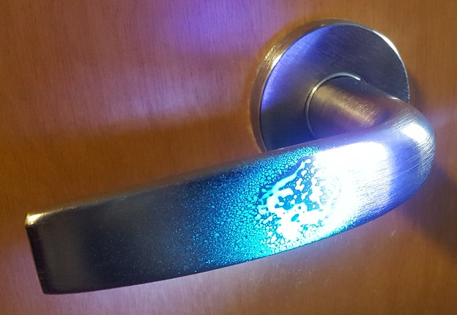
Prior to UV Marking Spray UV Marking Spray: 0% Removed
Not Removed
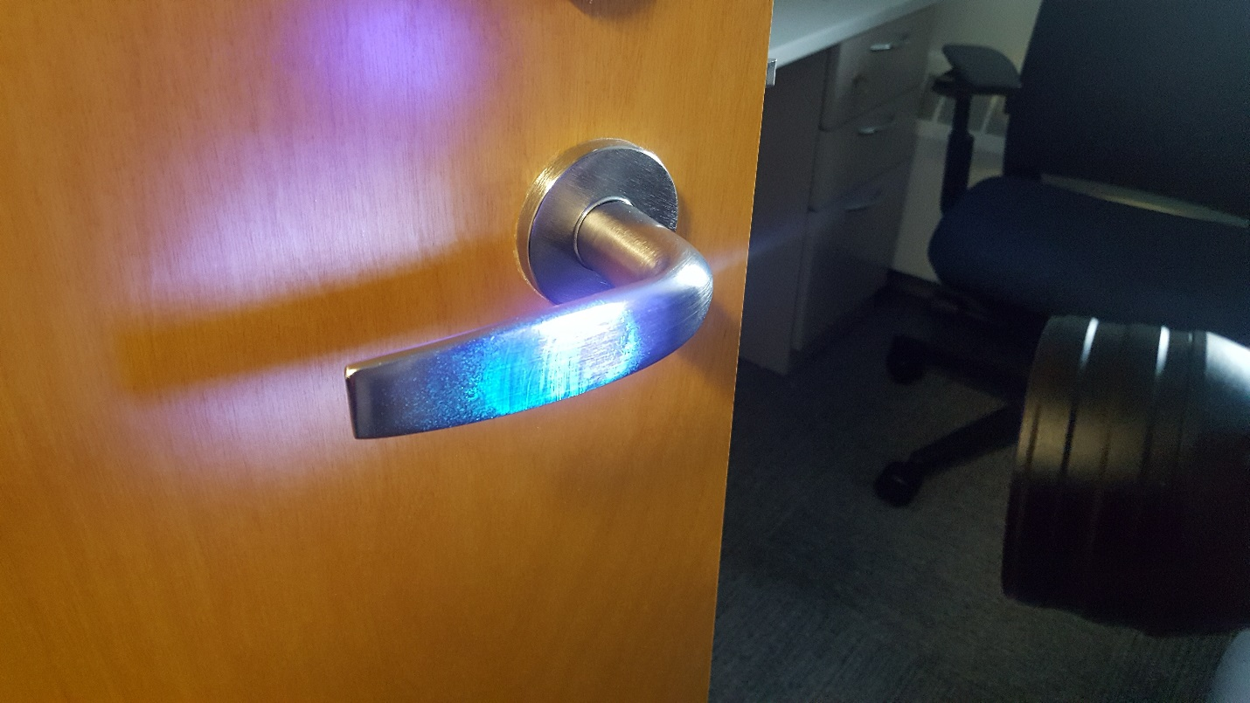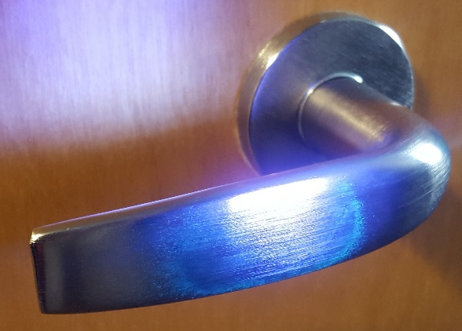
UV Marking Spray: 40% Removed UV Marking Spray: >80% Removed
Not Removed Removed

UV MARKING SPRAY REMOVAL: LIGHT SWITCH
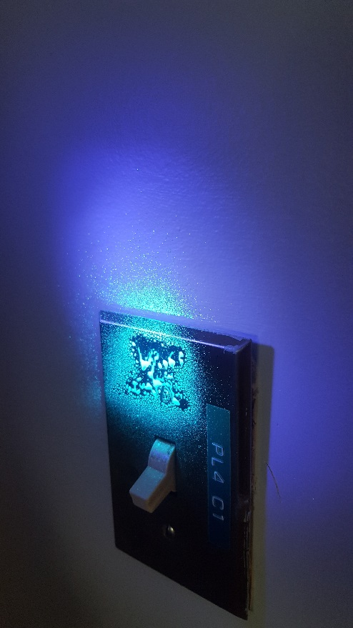
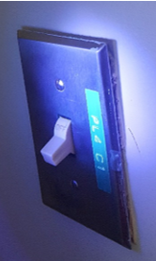
Prior to UV Marking Spray UV Marking Spray: 0% Removed
Not Removed
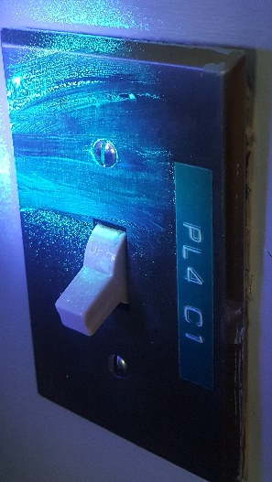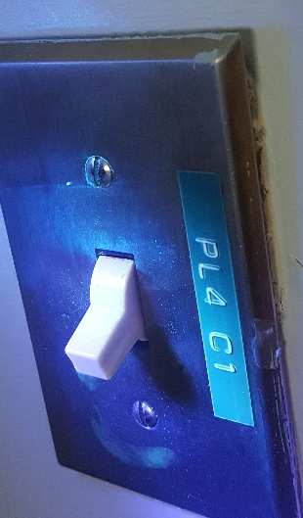
UV Marking Spray: 40% Removed UV Marking Spray: >80% Removed
Not Removed Removed

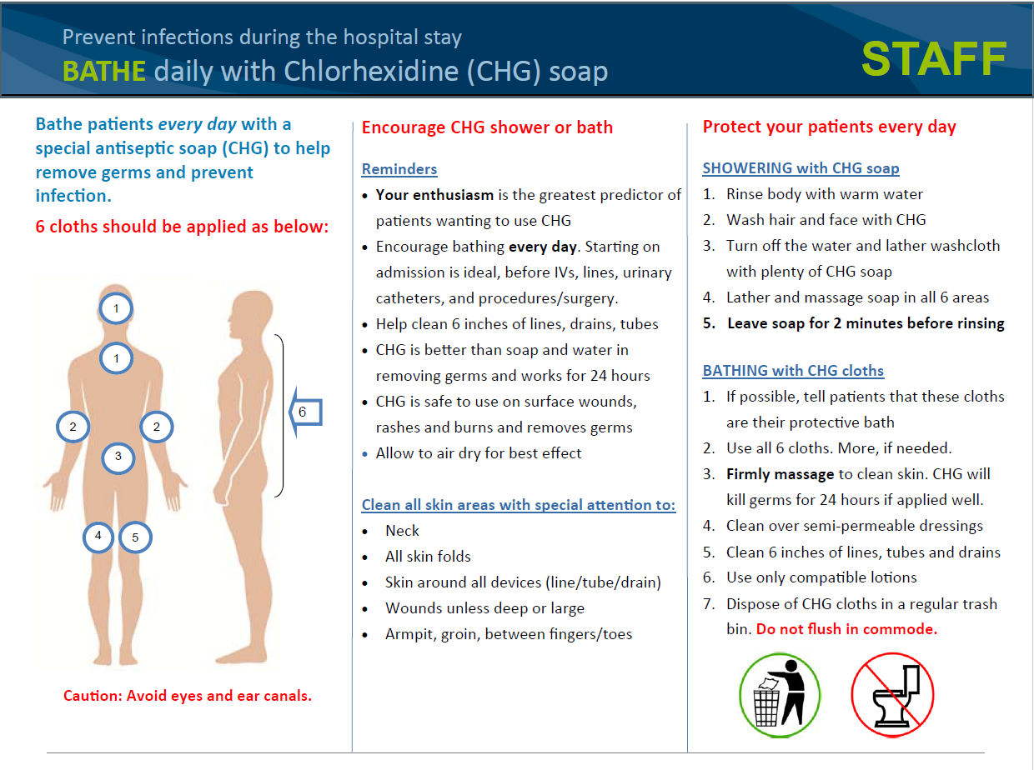

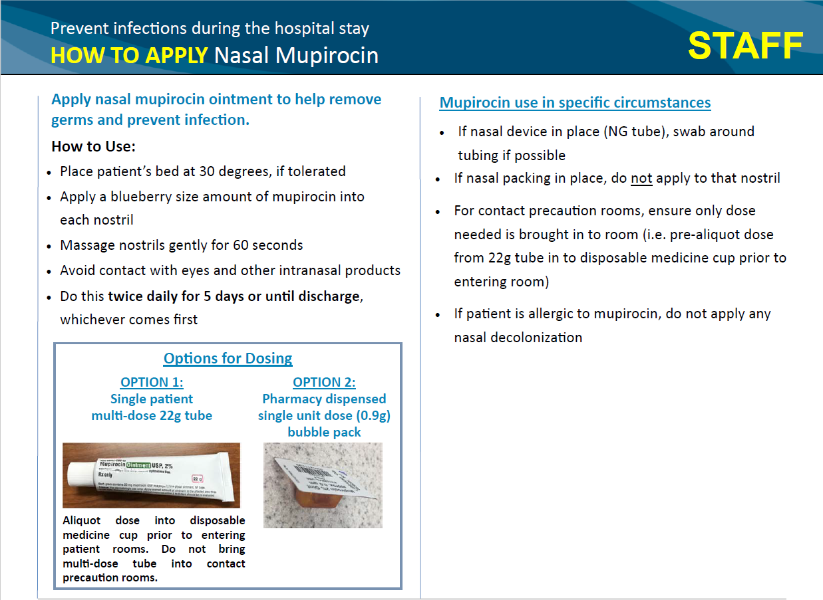
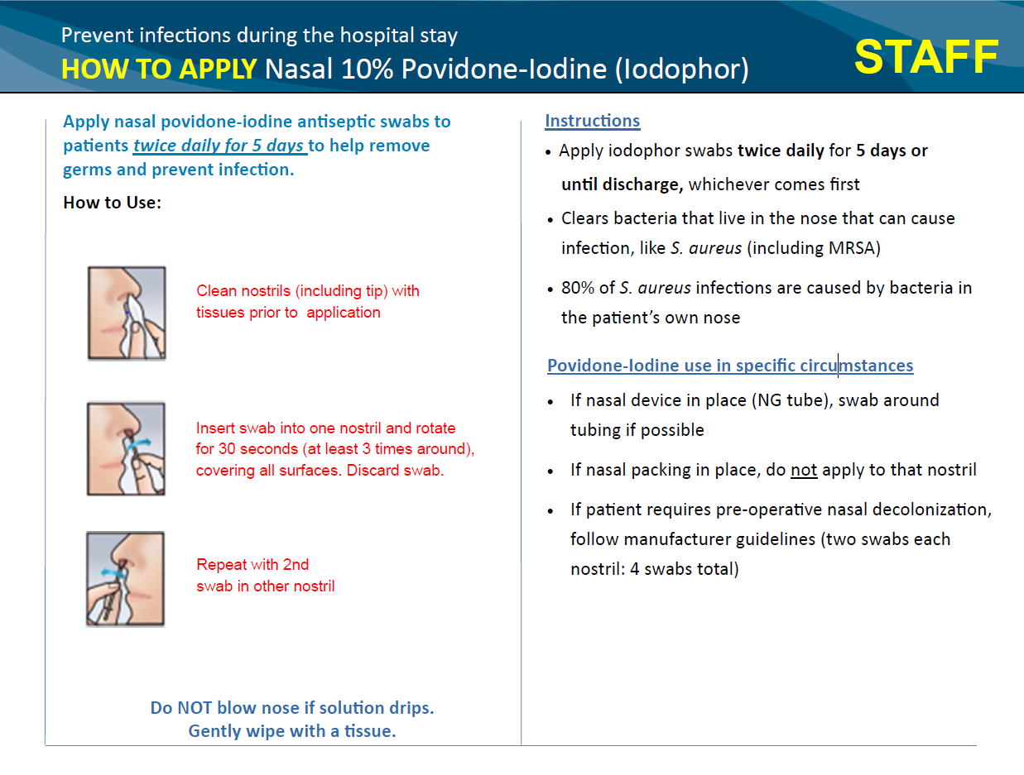

Outbreak Response Logs
Initial Response Log
- Day 1-2 Outbreak Response Log: Tier 1
- Day 1-2 Outbreak Response Log: Tier 2
- Day 1-2 Outbreak Response Log: Tier 3
- Day 1-2 Outbreak Response Log: Tier 4
- Day 1-2 Outbreak Response Log: Tier 5
Weekly Monitoring
- Weekly Intervention Log

Day 1-2 Outbreak Response Log

Facility Name: _________________________________ Submitted By: _________________________________

- Outbreak Progression Details:
  - How was the outbreak identified (describe): Click or tap here to enter text.
  - Outbreak descriptor: Click or tap here to enter text.
  - Date & Time when outbreak was identified: Enter MMDDYY; 00:00 AM/PM
  - Date & Time of collection of first isolate in outbreak: Enter MMDDYY; 00:00 AM/PM
  - Number of patients when outbreak was identified: Click or tap here to enter text.
- Organism: Click or tap here to enter text.
- Unit Director notification: Y/N 3a. Date & Time: Enter MMDDYY; 00:00 AM/PM
- Huddles with clinical staff have occurred: Y/N
- Complete initial practice assessments (using Outbreak Response Assessment Forms) & record results:
- Hand Hygiene Adherence Rate: ___________________%
- Contact Precaution Adherence Rate: _______________% (Check here if N/A and not completed: ☐)
- Environmental Cleaning Adherence Rate: ___________%
- Tier 2 intervention selected:

  - ☐ Improve hand hygiene
  - ☐ Improve contact precaution adherence
  - ☐ Improve quality of cleaning
  - ☐ Coordinated unit clean daily
  - ☐ Additional cleaning of high touch areas
  - ☐ Other (specify below)

- Intervention implementation Date & Time: Enter MMDDYY; 00:00 AM/PM
  - Description of intervention (indicate reason for selection, e.g. poorest adherence rate): Click or tap here to enter text.
- Additional Comments: Click or tap here to enter text.

Day 1-2 Outbreak Response Log: TIER 2 Progression of Outbreak

Facility Name: _________________________________ Submitted By: _________________________________

- Outbreak Progression Details:
- Outbreak descriptor: Click or tap here to enter text.
- Date & Time when outbreak progression was identified: Enter MMDDYY; 00:00 AM/PM
- Date & Time of collection of most recent isolate: Enter MMDDYY; 00:00 AM/PM
- Number of additional patients: Click or tap here to enter text.
- Please describe how the outbreak has progressed: Click or tap here to enter text.
- Huddles with clinical staff have occurred: Y/N
- Complete repeat practice assessments (if >1week has passed since initial assessments) & record results:
- Hand Hygiene Adherence Rate: ___________________%
- Contact Precaution Adherence Rate: _______________% (Check here if N/A and not completed: ☐)
- Environmental Cleaning Adherence Rate: ___________%
- Tier 2 intervention selected:

- ☐ Improve hand hygiene
- ☐ Improve contact precaution adherence
- ☐ Add universal glove precautions
- ☐ Add contact precautions for outbreak patients
- ☐ Improve quality of cleaning
- ☐ Coordinated unit clean daily
- ☐ Additional cleaning of high touch areas
- ☐ Other (specify below)

- Second intervention implementation Date & Time: Enter MMDDYY; 00:00 AM/PM
- Description of intervention (indicate reason for selection, e.g. poorest adherence rate): Click or tap here to enter text.
- Additional Comments: Click or tap here to enter text.

Day 1-2 Outbreak Response Log: TIER 3 Progression of Outbreak

Facility Name: _________________________________ Submitted By: _________________________________

- Outbreak Progression Details:
  - Outbreak descriptor: Click or tap here to enter text.
  - Date & Time when outbreak progression was identified: Enter MMDDYY; 00:00 AM/PM
  - Date & Time of collection of most recent isolate: Enter MMDDYY; 00:00 AM/PM
  - Number of additional patients: Click or tap here to enter text.
  - Please describe how the outbreak has progressed: Click or tap here to enter text.
- Huddles with clinical staff have occurred: Y/N
- Leadership Notification? Y/N
  - If yes, indicate who was notified:
  - Describe guidance and/or recommendations received: Click or tap here to enter text.
- Complete repeat practice assessments (if >1week has passed since initial assessments) & record results:
- Hand Hygiene Adherence Rate: ___________________%
- Contact Precaution Adherence Rate: _______________% (Check here if N/A and not completed: ☐)
- Environmental Cleaning Adherence Rate: ___________%
- Tier 3 intervention selected:

- ☐ Increase frequency of room cleaning
- ☐ Universal contact precautions for unit
- ☐ Weekly screening of patients on unit

- ☐ Initiate decolonization of affected patients
- ☐ Initiate decolonization of whole unit
- ☐ Improved routine decolonization procedures
- ☐ Other (specify below)

- Additional intervention implementation Date & Time: Enter MMDDYY; 00:00 AM/PM
  - Intervention description: Click or tap here to enter text.
  - If ‘Improved decolonization’ intervention is selected, record assessment results:
CHG Bathing Practices Adherence Rate: ___________% (Check here if not completed: ☐)
- Additional Comments: Click or tap here to enter text.

Day 1-2 Outbreak Response Log: TIER 4 Progression of Outbreak

Facility Name: _________________________________ Submitted By: _________________________________

- Outbreak Progression Details:
- Outbreak descriptor: Click or tap here to enter text.
- Date & Time when outbreak progression was identified: Enter MMDDYY; 00:00 AM/PM
- Date & Time of collection of most recent isolate: Enter MMDDYY; 00:00 AM/PM
- Number of additional patients: Click or tap here to enter text.
- Please describe how the outbreak has progressed: Click or tap here to enter text.
- Huddles with clinical staff have occurred: Y/N
- Leadership Notification? Y/N
  - If yes, indicate who was notified:
  - Describe guidance and/or recommendations received: Click or tap here to enter text.
- Complete repeat practice assessments (if >1week has passed since initial assessments) & record results:
- Hand Hygiene Adherence Rate: ___________________%
- Contact Precaution Adherence Rate: _______________% (Check here if N/A and not completed: ☐)
- Environmental Cleaning Adherence Rate: ___________%
- Tier 4 intervention selected:

- ☐ Increase frequency of room cleaning
- ☐ Universal contact precautions for unit
- ☐ Weekly screening of patients on unit

- ☐ Initiate decolonization of affected patients
- ☐ Initiate decolonization of whole unit
- ☐ Improved routine decolonization procedures
- ☐ Other (specify below)

- Additional intervention implementation Date & Time: Enter MMDDYY; 00:00 AM/PM
- Intervention description: Click or tap here to enter text.
- If ‘Improved decolonization’ intervention is selected, record assessment results:
CHG Bathing Practices Adherence Rate: ___________% (Check here if not completed: ☐)
- Additional Comments: Click or tap here to enter text.

Day 1-2 Outbreak Response Log: TIER 5 Progression of Outbreak

Facility Name: _________________________________ Submitted By: _________________________________

- Outbreak Progression Details:
- Outbreak descriptor: Click or tap here to enter text.
- Date & Time when outbreak progression was identified: Enter MMDDYY; 00:00 AM/PM
- Date & Time of collection of most recent isolate: Enter MMDDYY; 00:00 AM/PM
- Number of additional patients: Click or tap here to enter text.
- Please describe how the outbreak has progressed: Click or tap here to enter text.
- Huddles with clinical staff have occurred: Y/N
- Leadership Notification? Y/N
  - If yes, indicate who was notified:
  - Describe guidance and/or recommendations received: Click or tap here to enter text.
- Complete repeat practice assessments (if >1week has passed since initial assessments) & record results:
- Hand Hygiene Adherence Rate: ___________________%
- Contact Precaution Adherence Rate: _______________% (Check here if N/A and not completed: ☐)
- Environmental Cleaning Adherence Rate: ___________%
- Tier 5 intervention selected:

- ☐ Deep clean unit
- ☐ Screen staff
- ☐ Other (specify below)

- Additional intervention implementation Date & Time: Enter MMDDYY; 00:00 AM/PM
- Intervention description: Click or tap here to enter text.
- Additional comments: Click or tap here to enter text.

Weekly Intervention Log
Complete Intervention Log weekly, following implementation of response protocol.
Weekly Log should capture repeat practice assessment results for the week being reported.
Continue weekly reporting for duration of intervention, should it exceed the standard 3 weeks.

Facility Name: _______________________________ Submitted By: _________________________________

- Outbreak descriptor: Click or tap here to enter text.
- Outbreak Response Tier:
☐ Tier 1 ☐ Tier 2 ☐ Tier 3 ☐ Tier 4 ☐ Tier 5
- Indicate which week of the intervention that is being reported here:
☐ Week 1 ☐ Week 2 ☐ Week 3 ☐ Week 4 ☐ Week 5 ☐ Week 6
- Intervention selected:
Tier 1 & 2 options

- ☐ Improve hand hygiene
- ☐ Improve contact precaution adherence
- ☐ Add universal glove precautions
- ☐ Add contact precautions for outbreak ___patients
- ☐ Improve quality of cleaning
- ☐ Coordinated unit clean daily
- ☐ Additional cleaning of high touch areas

Tier 3 & 4 options

- ☐ Increase frequency of room cleaning
- ☐ Universal contact precautions for unit
- ☐ Weekly screening of patients on unit
- ☐ Initiate decolonization of affected patients
- ☐ Initiate decolonization of whole unit
- ☐ Improved routine decolonization procedures
Tier 5 options

- ☐ Deep clean unit
- ☐ Screen staff
- Intervention implementation Date & Time: Enter MMDDYY; 00:00 AM/PM
- Results of repeated practice assessments from this past week (complete only those applicable):
  - Hand Hygiene Adherence Rate: ___________________% (Check here if not completed: ☐)
  - Contact Precaution Adherence Rate: _______________% (Check here if not completed: ☐)
  - Environmental Cleaning Adherence Rate: ____________% (Check here if not completed: ☐)
  - CHG Bathing Practices Adherence Rate: _____________% (Check here if not completed: ☐)

- Additional Comments: Click or tap here to enter text.
- Please indicate if this outbreak was reported to your local or state health department (check one):
☐ Not reported ☐ Reported to state health department; report date: Click or tap here to enter text.
☐ Reported to local health department; report date: Click or tap here to enter text.

